

***Happy New Year from Activities!***

November & December 2024 was a busy couple of months for us. We started November with the Melbourne Cup and celebrated Diwali with delicious food and dance by the families of Cairnfield caregivers.

We had all our usual musicians through November and December and enjoyed extra community groups performing over the Christmas period.

Throughout December, we also enjoyed our residents Christmas party, the Mayoral Concert, and our volunteers’ lunch where we gave appreciation to all our fantastic volunteers that help our rest home run.

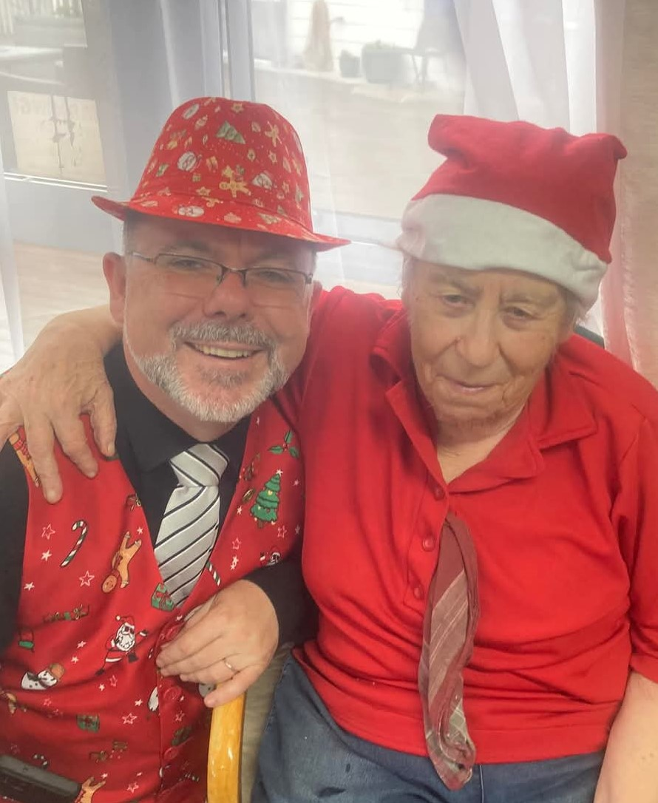

This year for the first time we participated in the Hikurangi Christmas Parade. It was a lot of fun.

Santa made a visit on Christmas Day, and we appreciate and thank all our staff who worked over the Christmas and New Year period.

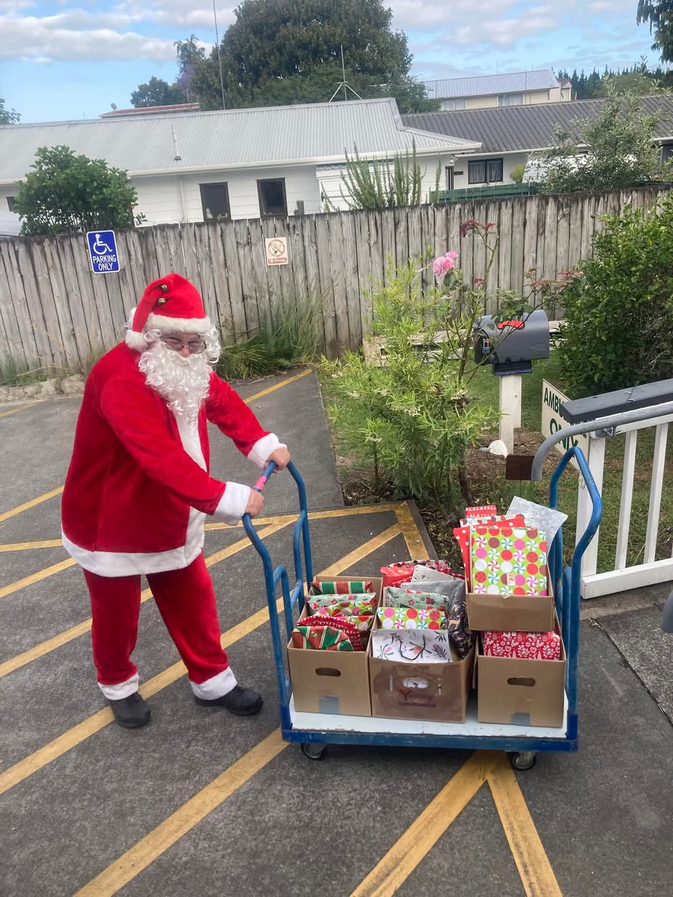

We had a bagpiper and drummer perform to end 2024 and welcome 2025.

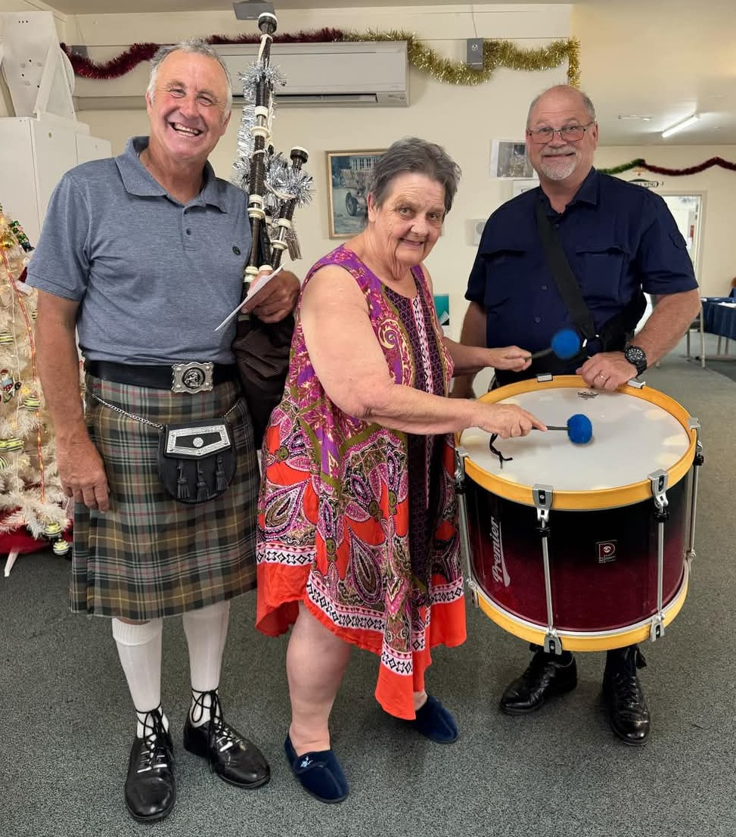

Congratulations to Anju who finished her Diversional Therapy studies in December. Well done on all your hard work.

We are so lucky to be able to bring back all our musicians and volunteers in 2025.

Wishing everyone health and happiness for 2025.

***Kia mau, kia koa***

**Mandy 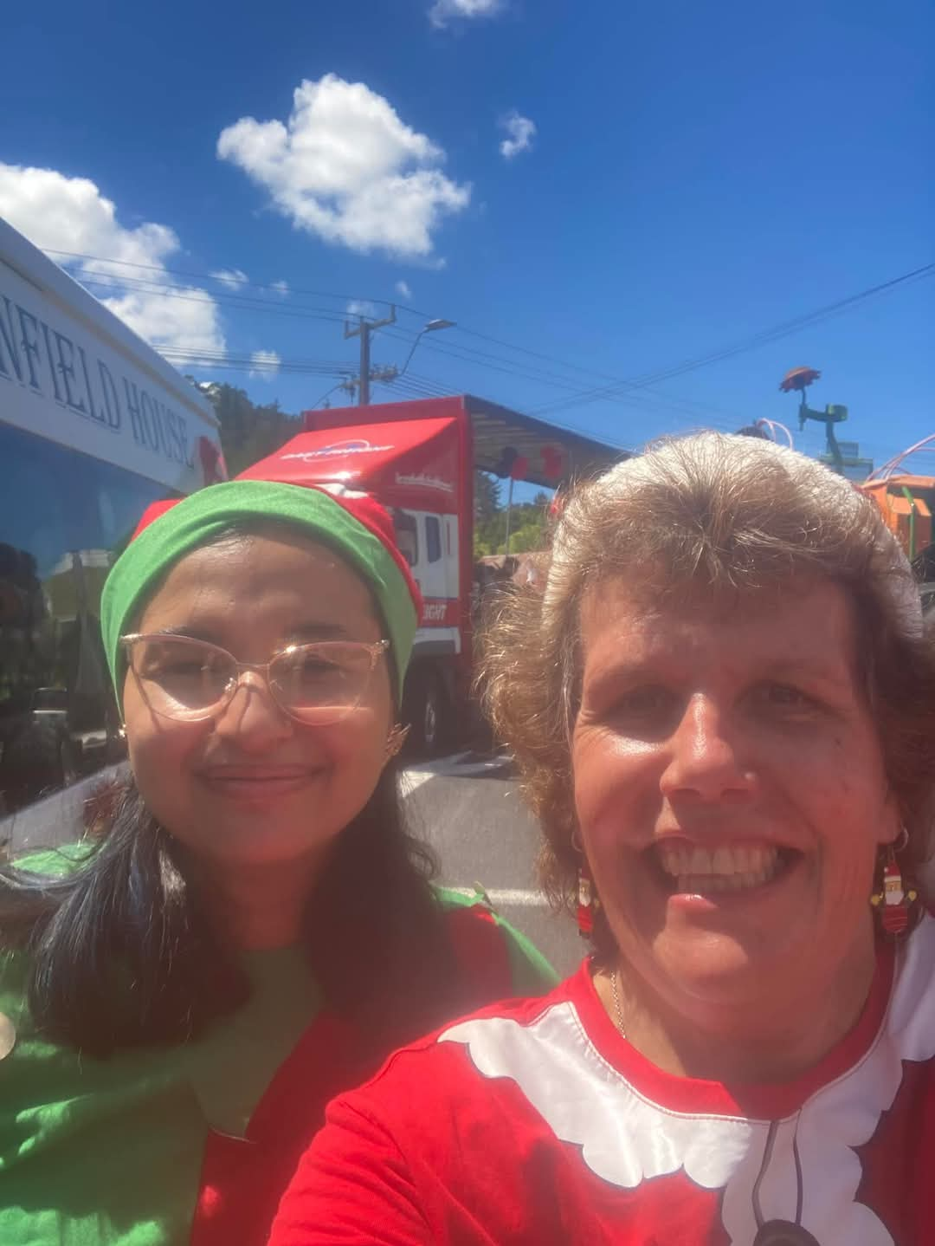 Anju**

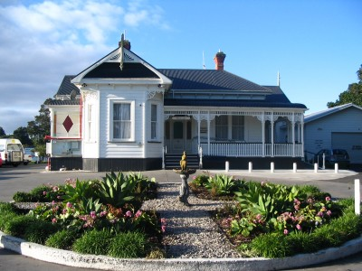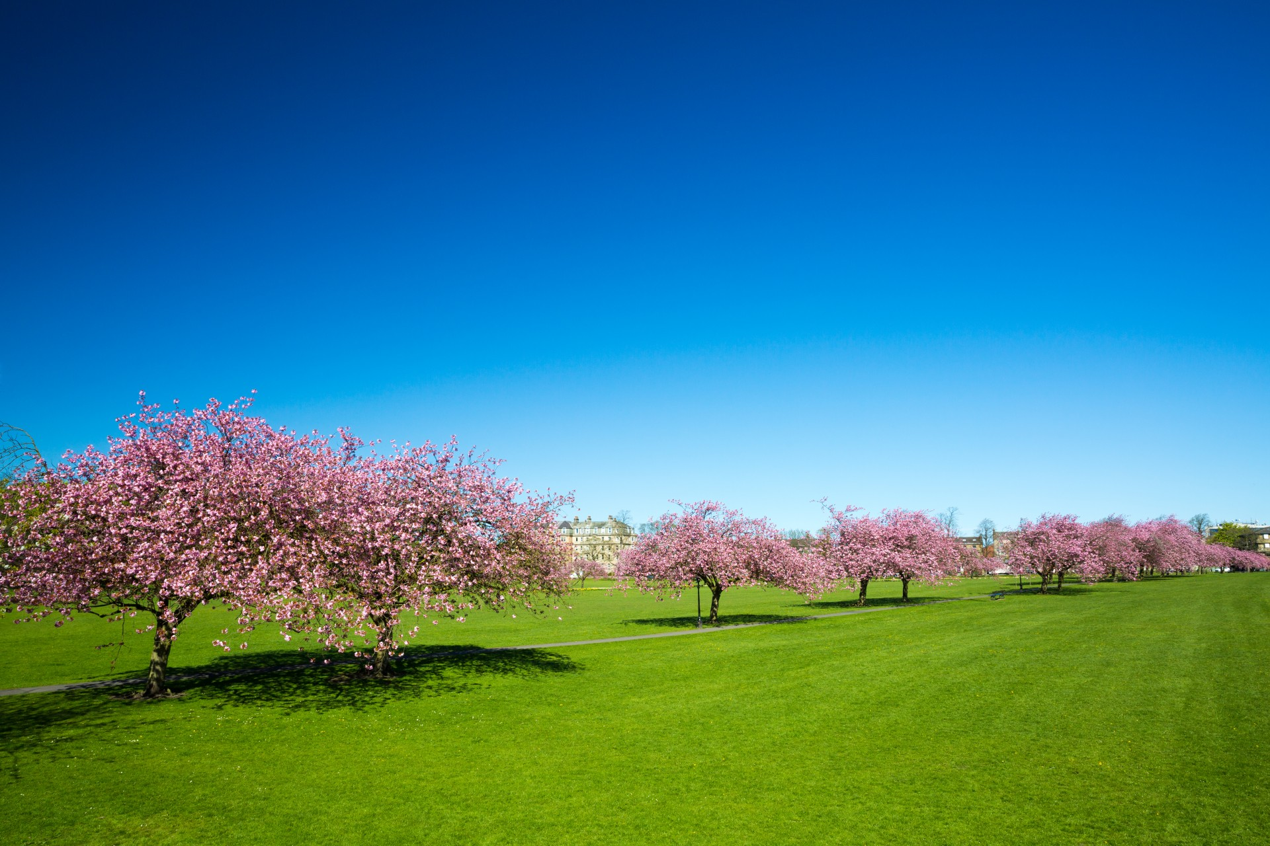

CAIRNFIELD HOUSE REST HOME AND HOSPITAL

“Whare okioki me te Hohipera”

**Message from our Facility Manager**

**“Hello and Happy New Year to you all. Here’s to more love, laughter, and memories to share together in the coming year with you and your loved ones."**

**Christmas has been and gone and this week our wonderful decorations throughout the house have been taken down. Thank you to the staff who gave of their time to do this. The house is now looking quite bare.**

**Our residents had a wonderful Christmas party, and it was a busy time on Christmas day with a lot going out to their whanau. We also welcomed many visitors from far and wide to the house. Thank you to our wonderful cook, kitchen assistants and staff for providing such a lovely lunch and ambience within the house which was enjoyed by all.**

**During 2024 we said goodbye to some of our Cairnfield Family (both Resident's and Staff) due to many reasons, and we welcomed many new ones as well.**

**As our focus now shifts toward an exciting 2025, once per month we will continue to offer cultural dishes from around the world that are requested by our residents at their meetings.**

**Anju has also completed her Diversional Therapist training, so we have two fully trained DT’s planning to deliver an exciting 2025 activities programme.**

**On a personal level, I will be out of action for several weeks from end of January, as I am booked in for knee surgery. I’m looking forward to being free of my crutches. Kind Regards**

**Lesley Middleton** 

[](https://www.bing.com/images/search?q=facebook+logo&id=C747D35005B1CC073B38CC977E3A7E15E2E067CC&FORM=IQFRBA)

**Remember to like us on Facebook to see what we get up to!**

## [**https://www.facebook.com/Cairnfieldhouse/**](https://www.facebook.com/Cairnfieldhouse/)

**Residents Clothing -** Please ensure your family member/whanau/friend that is staying with us has their personal clothing items named – this way we can ensure residents receive the correct items back from our laundry.

**Changes & Improvements at Cairnfield House**

The house extension is now complete with new carpet and new curtains.

“WHERE QUALITY & LOVING CARE IS ASSURED”

**Changes & Improvements at Cairnfield House**

* Additional Vehicle
* Tints taken off the Cairnfield van windows so our residents can see outside when on outings.
* We are fully staffed.

**RECENT TESTIMONIAL**

12345

**Appreciation for care from a recent respite resident!**

***“Thank you to every sincere caring person who I very much miss now I am at home. I suppose the decorations are all up and glittering away. May the New Year bring many good things into your life”.*  
The name Cairnfield House came from the ground it was built on, as “cairn” means a stony field in Scottish Gaelic. This elegant home was built in 1904 and apart from a new roof, the house is in its original state – even including some of the wallpaper.**

**SUMMER NEWSLETTER 2025**

## **Cairnfield House Rest Home & Hospital**

## **Contact: Lesley Middleton / Facility Manager**

## **Email:** [**lhauraki@cairnfieldhouse.co.nz**](mailto:lhauraki@cairnfieldhouse.co.nz)

## **52-60 Jack Street, Otangarei, Whangarei**

## **Phone: 09 4370186 ext 6**

## [**https://www.facebook.com/Cairnfieldhouse/**](https://www.facebook.com/Cairnfieldhouse/)